**Rituals Forum**

Mission: Programming Technical Questions and Answers

5+ тоест 80 точки

**Technology**

C# + ASP.NET MVC + Entity Framework + SQL Server + HTML + CSS

**Requirements**

Your project should implement **at least** the following **functionality**:

* User **registration** (and optionally user profiles) / **login** / **logout**.
* **View** all questions (optionally by category, optionally with paging), without a login.
* Ask a **new question** by the forum users (after login). Optionally question may have **tags** and **category**.

Larger teams should develop **larger projects**. The minimum number of application pages and database tables required for the project depend on the **count of team members**.

* Minimum (3 + **team_members_count**) **pages** (views).
* Minimum **team_members_count** **database tables** (or data collections / entities).
* Implement user registration, login, view content, create content.
* Implement **more functionality** by choice. Larger teams should implement more functionality.

**Optional Functionality**

* Add a WYSIWYG HTML Editor – 1 ден
* Implement **tags** for the forum questions. – 1 ден
  + Въпроси
    - Отговори
  + На Теми
  + На юзъри
  + Таговете ще са свободен текст бокс под поста
* Implement **categories** for the forum questions. – 1 ден
  + Админите
  + Implement add / edit / delete category in the admin panel
* Implement adding **answers** to the questions by the forum visitors – each visitor must fill out his name, email (optionally) and comment text. – 2 до 3 дни
  + Post new comment. Anonymous users can specify their name. Logged-in users use their profile name.
* **Counter** for visits for each question. – 1 ден
* Implement **ranking** according to user activity. – 3 дни
  + Every answer has its points given by the users and the user with the most points has the highest rank.
* Functionality for **searching** by question, answer and tags. – 1 ден
* **Admin panel** – 7 дни
  + Admin Panel with Icons
  + Edit Posts, Edit Comments, Edit Categories, Edit Tags, Edit Users, Edit Pictures
* Add Roles – 2 ден
  + User
    - Comment
    - Upload Pictures
    - Redact answer and question
  + Administrator
    - All access
  + Moderator
    - Redact Posts
    - Delete Posts
    - Delete Answers
* Comments със цитати will be displayed in quotes with the authors name and time – 1 ден
* Deleted posts will delete all related links – 1 ден
* Notifications to answers – 1 ден
* Reactions to a registered user will be displayed first upon login and then under the normal posts – 1 ден
* Anchor to the top of the page

**Super Optional**

* Automatic Avatar Generation

**Team Members and Responsibilities**

|  |  |
| --- | --- |
| **Person** | **Tasks** |
| Angelina | Graphic Design |
| Luboslav | C# Back End & Front End |
| Antoan | Front End & C# Back End |
| Jay D | C# Back End |
| Angel | C# Back End |
| Denis | C# Back End |

**Home Page**

* New posts on the front page

User Name

Logo

Avatar

LogOut

**Topics by Category**

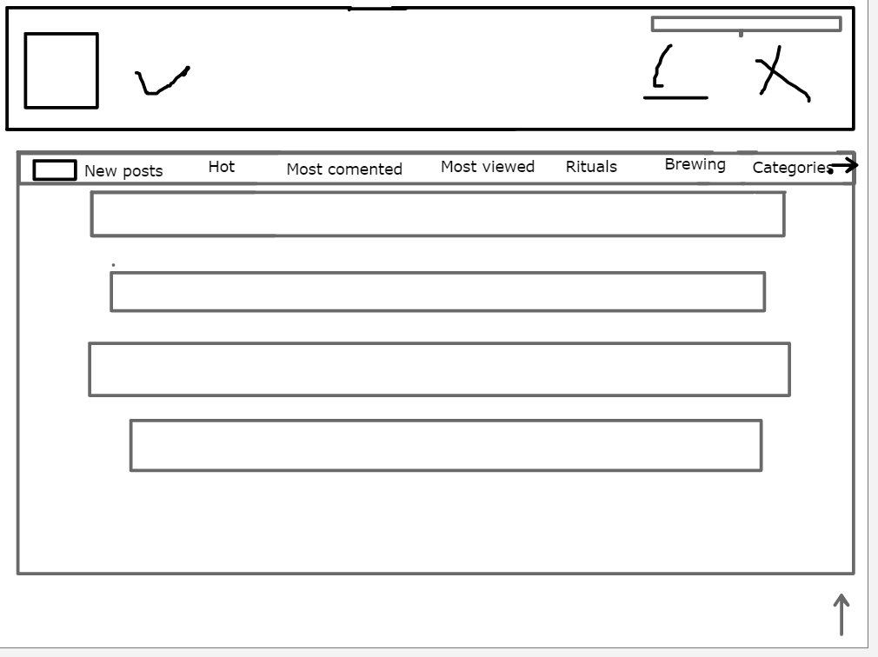

**User Home Page**

User Name

LogOut

Avatar

Logo

**Reactions to Posts and Questions**

**Topics By Category**

**General Topics**

**User Post**

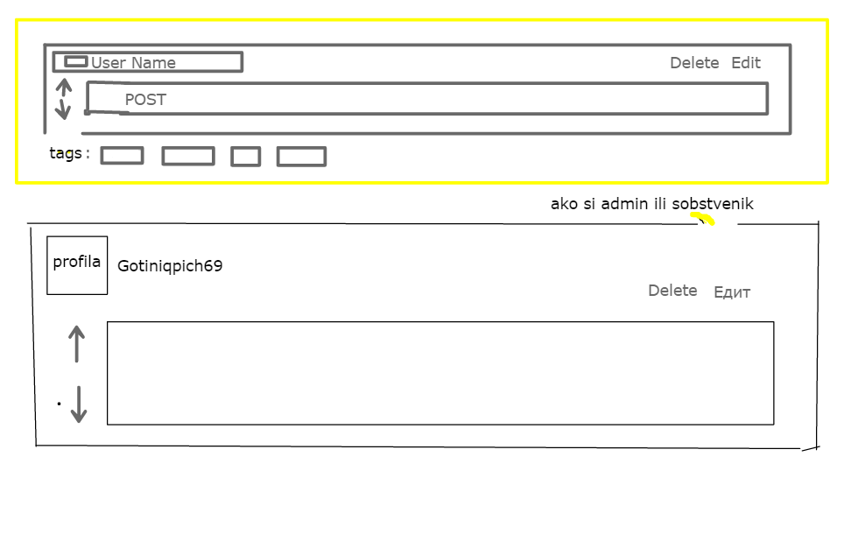

**Admin Panel**

